Bank Reconciliation Procedure in QuickBooks
Bank reconciliation in QuickBooks is a critical accounting process that ensures your business records match your bank's records. This process helps detect discrepancies, prevent fraud, and maintain accurate financial reports. Follow the steps below to perform a successful bank reconciliation:

1. Gather Bank Statement Information
Obtain the bank statement for the period you wish to reconcile. Note the beginning balance, ending balance, and the statement ending date.

2. Open the Reconciliation Tool in QuickBooks
Go to Accounting > Reconcile. Select the appropriate bank account. Enter the statement ending balance and ending date. Click Start Reconciling.
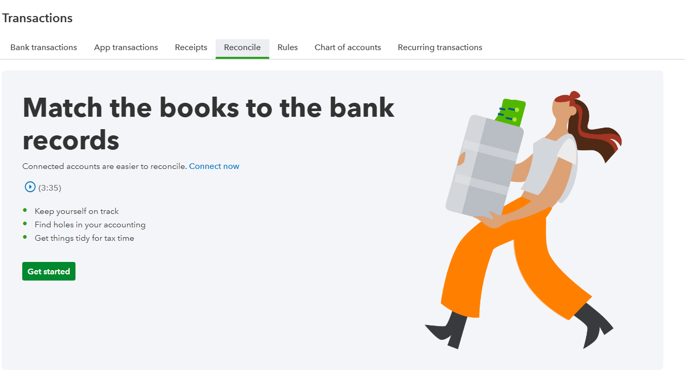
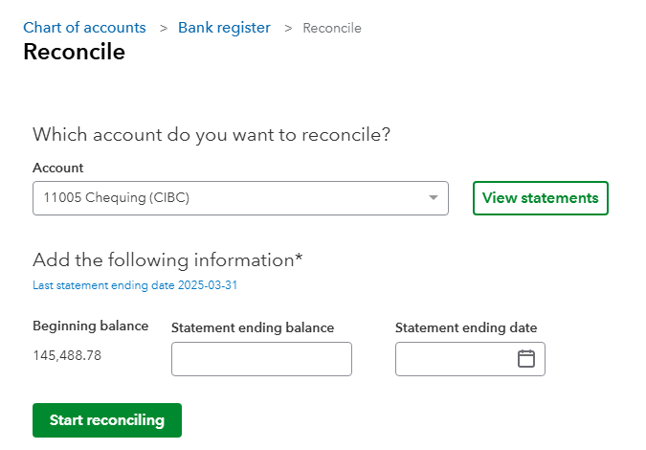

3. Match Transactions

a. Beginning Balance Check
Verify that the beginning balance in QuickBooks matches the opening balance on your bank statement. If there is a discrepancy, investigate previous reconciliations for errors or deleted transactions.

b. Match Deposits and Credits
Check off all deposits and credits that appear on your bank statement. Ensure the amounts and dates match.

c. Match Withdrawals and Debits
Check off all withdrawals, checks, and other debits listed on the bank statement. Confirm the amounts and dates.

4. Review Unmatched Transactions
Identify any transactions in QuickBooks that do not appear on the bank statement. These may include uncleared checks or deposits in transit. Ensure they are legitimate and expected to clear in a future period.

5. Resolve Discrepancies
Investigate any differences between QuickBooks and your bank statement. Common issues include duplicate entries, missing transactions, or incorrect amounts. Make adjustments as needed.

6. Finalize the Reconciliation
Once the difference is $0.00 and all items are accounted for, click Finish Now. Save or print the reconciliation report for your records.
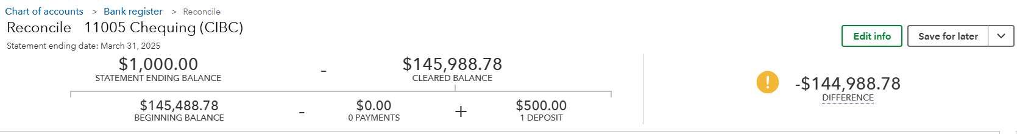

Best Practices
- Reconcile bank accounts monthly to ensure accurate financial records.
- Investigate and resolve discrepancies immediately to avoid compounding errors.
- Use the bank feed feature in QuickBooks to reduce data entry errors and simplify matching. – See schedule A
- Lock periods after reconciliation to prevent accidental changes to cleared transactions. -See schedule A
- Keep detailed notes and documentation for any adjustments made during reconciliation.

Schedule: Using Bank Feed & Locking Periods in QuickBooks

A. Using the Bank Feed Feature
The Bank Feed feature allows automatic import of transactions from your financial institution, reducing manual entry and increasing accuracy.

1. Connect Your Bank Account
Go to Banking or Transactions > Link Account, search for your bank, and sign in securely to connect your account.

2. Review Imported Transactions
Transactions appear under the 'For Review' tab. Review and categorize each one.

3. Match to Existing Transactions
QuickBooks attempts to match imports to existing entries. Approve matches or add new ones.

4. Use Rules to Automate Categorization
Go to Banking > Rules to create automation for recurring transactions.
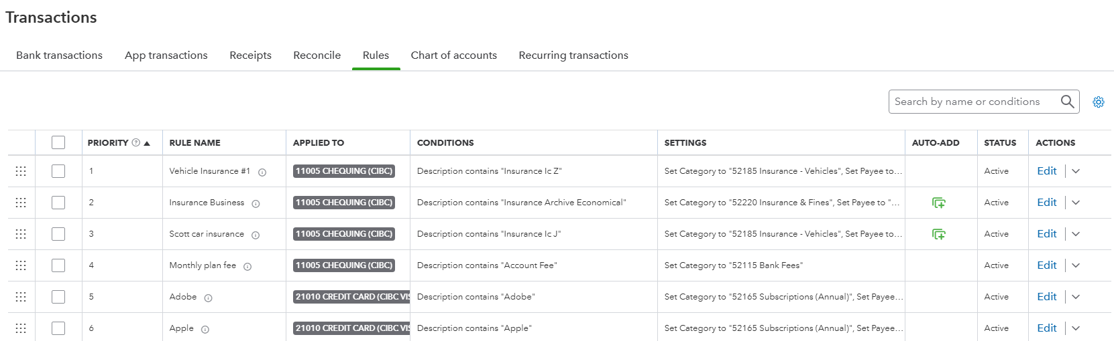

5. Reconcile Monthly
After reviewing all transactions, perform regular monthly reconciliation from Accounting > Reconcile.

B. Locking Periods in QuickBooks
Locking periods prevents changes to previously reconciled data and finalized reports, helping to maintain data integrity.

1. Navigate to Account Settings
Click the Gear icon (⚙) > Account and Settings.

2. Enable Closing the Books
Go to the Advanced tab > Accounting section > Turn on Close the books.
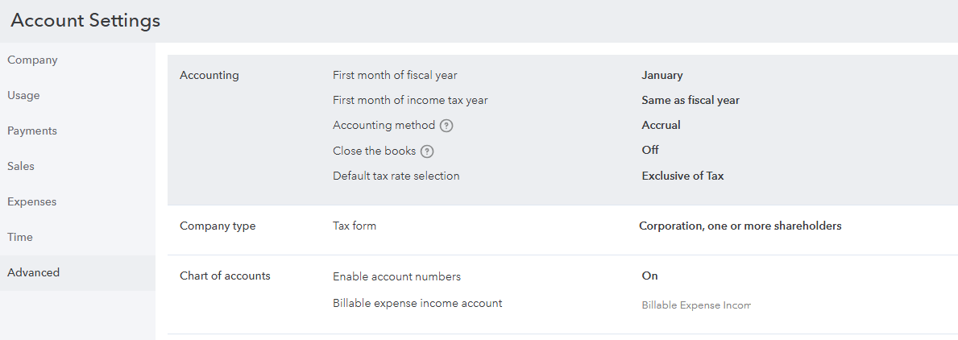

3. Set the Closing Date
Enter the last date of the reconciled period. Choose to warn or require a password for changes.
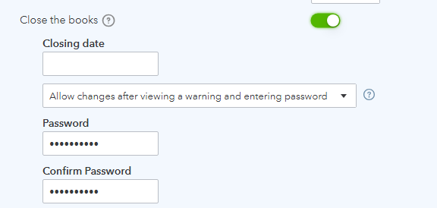

4. Save Changes
Click Save, then Done to finalize the settings.

Best Practices
- Reconcile and then lock periods immediately to prevent unintended changes.
- Require a password for editing closed periods to add an extra layer of protection.
- Use transaction rules for recurring items to speed up reviews in the Bank Feed.
- Regularly review the Audit Log for changes made after periods are locked.

