How to Use the Bank Feed in QuickBooks Online (QBO)
The Bank Feed is a real-time link between your bank/credit card accounts and QuickBooks. It automatically imports your transactions into QuickBooks, helping you stay up to date and reduce manual entry.

Step-by-Step: Using the Bank Feed

1. Connect Your Bank Account
1. Go to Banking or Transactions > Bank transactions.
2. Click 'Link account'.
3. Choose your bank and follow the prompts to sign in securely.
4. Select the account(s) to connect.
5. Choose the date range to import transactions from.
Tip: Choose a recent date if you want to avoid duplicate data with already recorded transactions.

2. Review and Categorize Transactions
1. Click on each transaction to expand the details.
2. Select the appropriate Category (e.g., Office Expenses, Rent, Travel).
3. Add Vendor/Customer Name if applicable.
4. Add Tags if you want to track income/expenses by specific projects or internal tracking.
5. Add Notes for clarity if needed.
6. Click Add, Match, or Transfer, depending on the type of transaction.
- Add: Creates a new transaction in QBO. Please refer to “Matched_vs_Added QBO – SOP for detailed explanation.
- Match: Links with an existing transaction (e.g., a bill or invoice). Please refer to “Matched_vs_Added QBO – SOP for detailed explanation.
- Transfer: Moves money between your accounts.

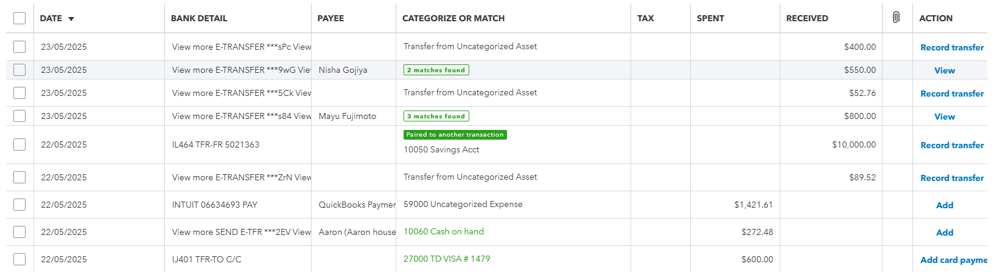

3. Use Rules to Save Time
1. Go to Banking > Rules.
2. Click 'New Rule'.
3. Create a rule based on criteria like description, amount, or bank text.
4. Assign a category, payee, and tags automatically.

Tags: Track Beyond the Chart of Accounts
Tags are custom labels you can add to transactions for additional tracking. They are ideal for events, campaigns, clients, or locations. Tags do not affect your accounting but help create management reports.
1. Open the transaction from the For Review tab or after it's been added.
2. Look for the Tags field and select or create a new tag.
3. Use Tag Groups to organize related tags (e.g., by project or team).

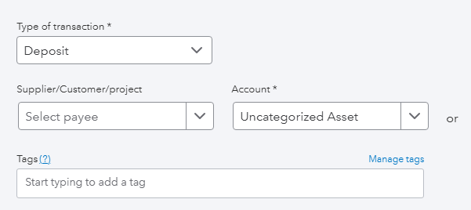

Categories: Keep Your Books Accurate
Categories are based on your Chart of Accounts and determine where each transaction is posted in your financial reports.
- Always choose the most accurate account.
- Avoid using generic categories like 'Uncategorized Expense.'
- Update your Chart of Accounts to reflect your business model.

Reporting with Bank Feeds, Tags, and Categories
- Profit and Loss: Based on categories.
- Tagged Transactions Report: View by tags or tag groups.
- Transaction Detail Reports: Filter by category or tags for deep analysis.

Tips for Accuracy
- Reconcile bank accounts monthly.
- Avoid duplicating entries—match before adding.
- Use memo and notes fields for clarity.
- Set up approval workflows if working with a team.

