Credit Card Reconciliation Procedure in QuickBooks
Reconciling your credit card accounts in QuickBooks ensures the accuracy of your financial records and helps detect discrepancies such as duplicate entries or fraudulent transactions. Follow these steps to perform an effective reconciliation:

Step-by-Step: Reconciling Credit Card

1. Prepare for Reconciliation
Obtain the credit card statement for the period to be reconciled. Note the statement beginning balance, ending balance, and statement date.

2. Open the Reconciliation Tool in QuickBooks
Go to Accounting > Reconcile. Select the appropriate credit card account. Enter the statement ending balance and statement ending date from your credit card statement. Click Start Reconciling.
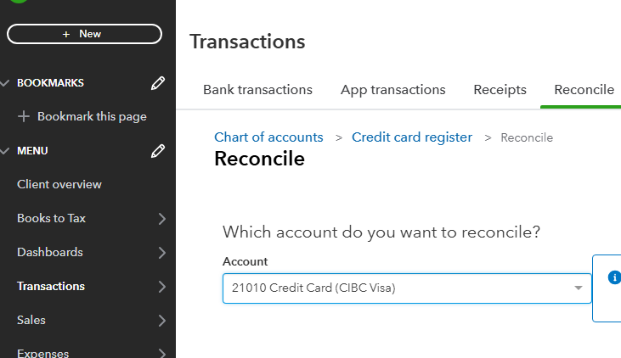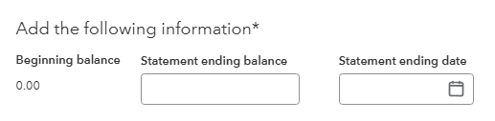

3. Match Transactions

a. Beginning Balance Check
Ensure the beginning balance in QuickBooks matches the opening balance on the statement. If not, investigate discrepancies from the prior period (e.g., unreconciled transactions or prior adjustments).

b. Clear Charges and Cash Advances
Match all purchases, fees, and advances shown on the credit card statement to transactions in QuickBooks. Check them off once confirmed.

c. Clear Payments and Credits
Match all payments and credits to the credit card made during the period. Check them off once they match the statement.
Note: Match transactions only within the statement period. If a purchase was made February 22 (per the credit card statement) but recorded in QBO on February 23, the corrective action would be to change the QBO posting date to February 22 and reconcile the item. Ignore transactions after the statement end date.

4. Verify the Ending Balance
Ensure the cleared balance in QuickBooks matches the ending balance on the credit card statement. The difference should be $0.00. If not, review unmatched or duplicate transactions.

5. Review Unreconciled Transactions
Any transaction dated within the reconciliation period but not on the statement should remain uncleared. These will likely appear on the next statement. Flag unusual or aged unreconciled items for further investigation. E.g., outstanding cheque greater than 6 months would be the aged unreconciled item, and voiding then reissuing the cheque using today’s date would be resolution.

6. Finalize and Reconcile
Once the difference is $0.00, click Finish Now. Save a copy of the reconciliation report for recordkeeping and audit trail purposes.
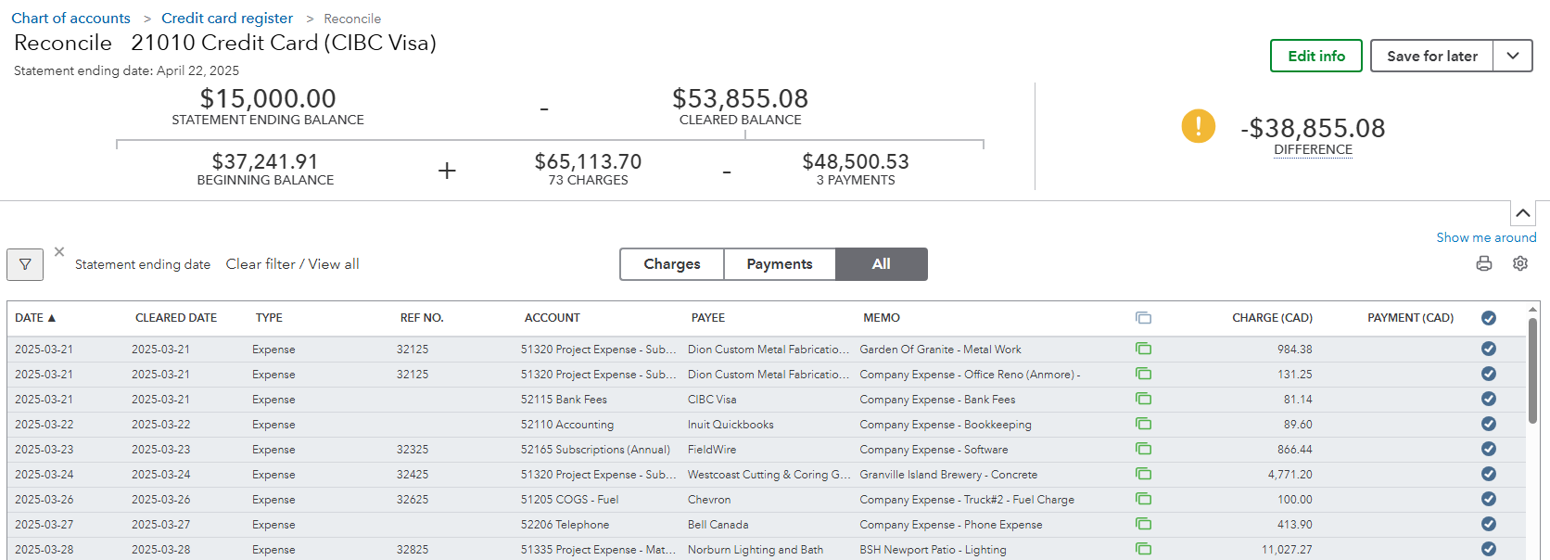

Common Mistakes:
- Expenses and bill payments are voided or deleted on the original date of the transaction instead of using today’s date. Transactions should never be changed in historical periods as it will throw off your account balances.
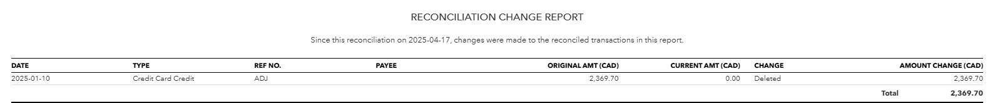

Best Practices
- Reconcile monthly as part of the month-end closing process.
- Investigate discrepancies promptly to ensure books are accurate.
- Lock reconciled periods to prevent accidental changes (use the Close the Books feature in QuickBooks under Settings > Advanced). 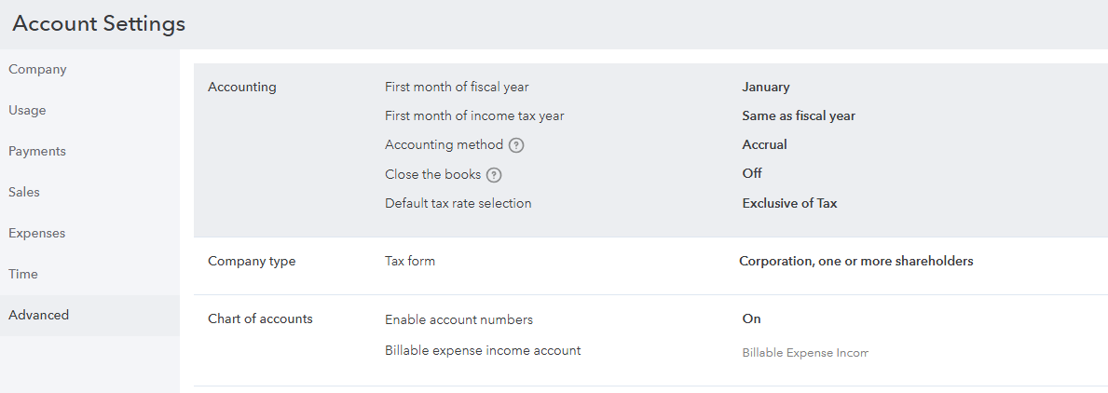
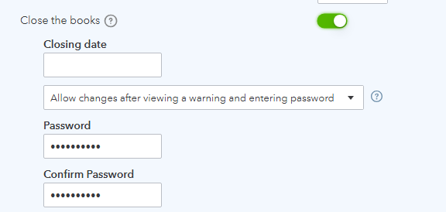
- Maintain a consistent naming convention for transactions to make matching easier.

Undoing a Bank Reconciliation in QuickBooks
If a reconciliation was done incorrectly (e.g., in January 2025), follow these steps to undo and redo the reconciliation properly.

QuickBooks Online
1. Go to the Gear icon (⚙) > Reconcile.
2. Select the relevant bank account.
3. Click 'History by account'.
4. Locate the January 2025 reconciliation, click 'View report'.
5. Click the drop-down beside 'View report' and select 'Undo'.
6. Confirm to undo the reconciliation.
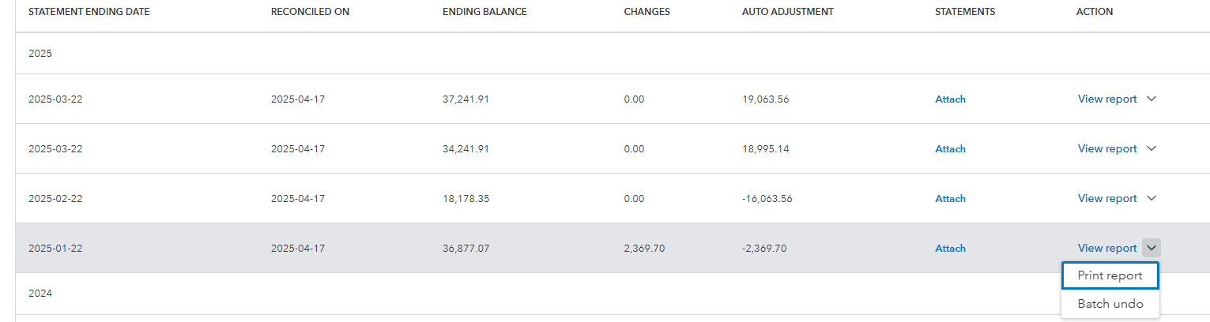

Re-Reconciling the Period
Once the incorrect reconciliation is undone, gather the correct January 2025 bank statement and follow standard reconciliation steps. Ensure all transactions are properly matched before finalizing.

