Fullhost login
Username: saltire.admin@badiee.com
Password: *** (all passwords will be provided separately)

Domain:
saltirecollective.com (main domain)
saltirecollective.ca (redirect to main domain)
DNS
Main domain DNS:
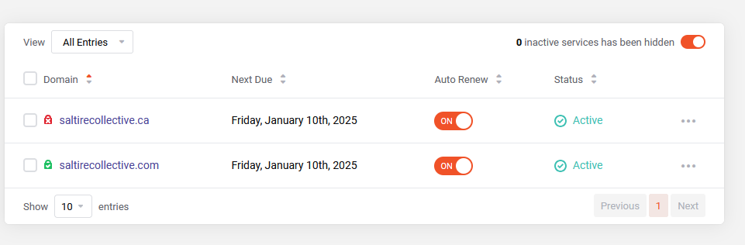
- Go to Domain -> My domain and then click the three dots next to domain name, then Manage Domain. OR, use the link below directly:
- https://manage.fullhost.com/clientarea.php?action=domaindetails&id=6415
- Click DNS management
- Do not change anything if you are unclear
- Make a note before making any changes
Redirect domain DNS:
- https://manage.fullhost.com/clientarea.php?action=domaindetails&id=6414
- Click DNS management
- Note the URL Redirect setting
- Do not change settings if you are unclear

VPS:
- Tier: Fullhost Starter plan
- OS: Ubuntu 22.04.5 LTS
- Web server: Nginx
- Application: FreeScout
- PHP version: 8.1.2
- IP: 162.223.226.53
- Host: index.saltirecollective.com
- Access: SSH key based. Generate or block SSH key at https://vcp.fullhost.com/sshkeys
- Database Host: localhost
- Database Port: 3306
- Database Name: freescout
- Database Username: freescout
- Database Password: ***
Server status: https://inbox.saltirecollective.com/system/status

Freescount
https://inbox.saltirecollective.com
Login: https://inbox.saltirecollective.com/login
Username: admin@saltirecollective.com
Password: ***
Mailbox setup:
Accounting mailbox config:
- Receiving: https://inbox.saltirecollective.com/mailbox/connection-settings/1/incoming
- Sending: https://inbox.saltirecollective.com/mailbox/connection-settings/1/outgoing
Azure AD app registration-based Email access. User-based API permissions. Do not change anything if unclear.
Receiving config:
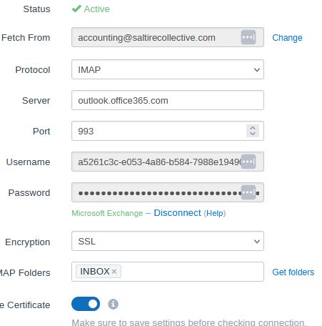

Username (Azure AD app ID): a5261c3c-e053-4a86-b584-7988e194908c
Password (Azure AD app registration API secret value): ***
Sending config:
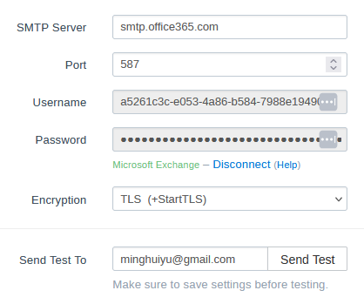
Sending & receiving use the same credentials
System email:
System email is to send system alerts, system notification, etc. It is different from mailbox email.
URL: https://inbox.saltirecollective.com/app-settings/emails
MFA enabled email can NOT be used as system email as it does not support modern authentication. Currently system email is using smtp2go’s service. Notice: system email is outbound only. Sign up a free smtp2go account, follow smtp2go’s documentation on setting up an SMTP user.

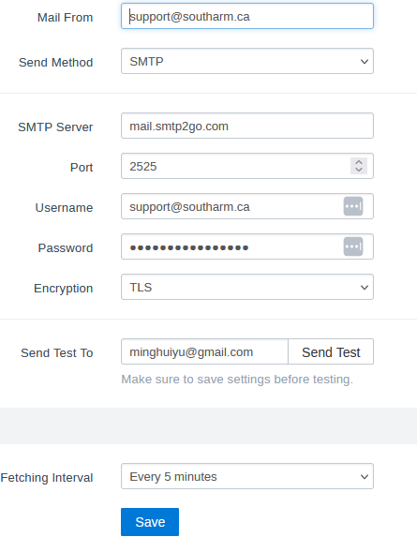

Azure
- Global admin: catchall@saltirecollective.com
- Password: ***
Security Default disabled upon request.
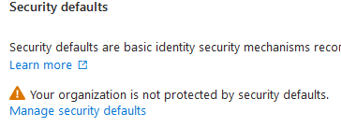
Azure App Registration (for Freescout)
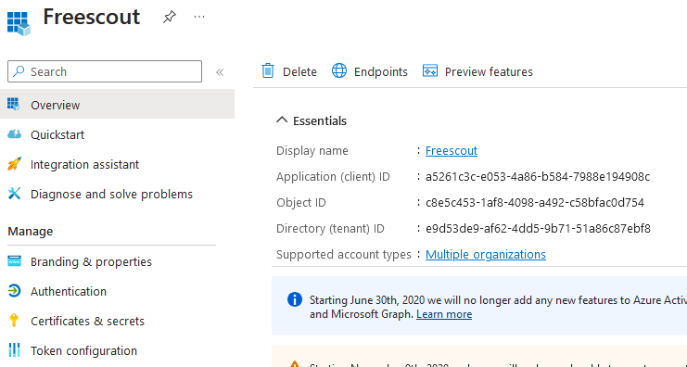
- Direct link: https://entra.microsoft.com/#view/Microsoft_AAD_RegisteredApps/ApplicationMenuBlade/~/Overview/appId/a5261c3c-e053-4a86-b584-7988e194908c/isMSAApp~/false
- App ID: a5261c3c-e053-4a86-b584-7988e194908c
- Certificate: Expires on 2025-10-08

Exchange

Two rules in place:
- Disclaimer & Signature: apply to all; using Exchange’s basic disclaimer settings.
- Catch-all: This workflow of this rule is
a) Change @saltirecollective.com from Authoritative to InternalRelay (in Exchange’s Accepted Domain configuration)
b) redirect all inbound external emails to catchall@saltirecollective.com
c) If recipient is internal, then bypass the above redirection

